Assignment Report: End to End MLOPS pipeline for heart disease prediction

Topic: End-to-End ML Model Development, Experiment Tracking, CI/CD, Containerization, Kubernetes Deployment, and Observability

1. Executive Summary
This report documents the design, implementation, and deployment of an enterprise-grade, reproducible machine learning solution for heart disease risk classification using the UCI Heart Disease Dataset. Developed in accordance with production MLOps best practices, the end-to-end pipeline automates data ingestion, model experimentation, continuous integration and continuous deployment (CI/CD), containerization, orchestration, and continuous monitoring.
Key Architecture Highlights & Technical Deliverables
- Data Engineering & Preprocessing: Automated data acquisition directly from the UCI Machine Learning Repository via ucimlrepo. Raw target labels ($0-4$) were transformed into a balanced binary target ($0=$ Absence, $1=$ Presence of disease). Feature preprocessing prevents data leakage through a sealed scikit-learn ColumnTransformer pipeline integrating StandardScaler for numerical metrics and OneHotEncoder for categorical variables.
- Model Experimentation & Tracking: Comparative evaluation of baseline Logistic Regression and Random Forest Classifier models evaluated using Stratified 5-Fold Cross-Validation. Experiment parameters, evaluation metrics (Accuracy, Precision, Recall, F1-Score, ROC-AUC), and visual artifacts were logged to a local MLflow tracking server.
- Reproducibility & Packaging: Complete model and preprocessing pipeline serialization into a unified model.pkl artifact, backed by a strict dependency environment (requirements.txt).
- Automated CI/CD Workflows: Implementation of a GitHub Actions CI/CD pipeline triggered on code pushes. The workflow automates code linting (flake8), unit testing (pytest), model execution, and automated release artifact packaging.
- Containerization & Orchestration: High-performance RESTful API built with FastAPI exposing /predict and /health endpoints. The service is packaged as a lightweight Docker container (python:3.10-slim) and deployed to a local Kubernetes cluster (Docker Desktop) utilizing Deployment manifests ($2$ replicas) and a LoadBalancer Service.
- Observability & Logging: Structured JSON request/response logging integrated into the FastAPI service, paired with a native Prometheus and Grafana observability stack monitoring real-time API traffic metrics, latency, and request rates.

2. Project Metadata & Key Performance Indicators
Pipeline Metric / Component | Value / Implementation Detail
Dataset Source | UCI Machine Learning Repository (Dataset ID: 45)
Target Variable | Binary Classification (0: Low Risk, 1: High Risk)
Selected Production Model | Random Forest Classifier ($100$ estimators, $\text{max_depth}=5$)
Primary Evaluation Metric | Test ROC-AUC / Test Accuracy
API Framework & Server | FastAPI with Uvicorn ASGI Server
Container Engine | Docker Engine (heart-disease-api:v2)
Orchestration Engine | Local Kubernetes Cluster (Docker Desktop / Minikube)
CI/CD Platform | GitHub Actions (.github/workflows/ci.yml)
Monitoring Stack | Prometheus metrics scraper + Grafana UI das

3. Problem Statement
Heart disease remains one of the leading causes of mortality globally. Early detection and risk assessment based on clinical metrics enable proactive interventions and improved patient outcomes. The primary objective of this project is to develop, train, package, and deploy a scalable, reliable, and reproducible machine learning classifier capable of predicting the risk of heart disease in patients based on routine diagnostic metrics.
Beyond standalone model accuracy, the core focus of this assignment is operationalizing the machine learning workflow using modern MLOps principles. This requires creating an end-to-end pipeline that ensures:
- Automated and deterministic data fetching and cleaning.
- Modular feature preprocessing without data leakage.
- Full tracking of experiments, metrics, and parameters.
- Automated CI/CD integration with strict unit testing.
- Isolated containerization and scalable local Kubernetes orchestration.
- Real-time request logging and continuous observability.

4. Dataset Characteristics & Data Acquisition Pipeline
4.1 Dataset Overview
The project utilizes the benchmark Heart Disease UCI Dataset obtained directly from the UCI Machine Learning Repository (Dataset ID: 45). The dataset contains 303 patient records with 13 health features and 1 target attribute.
Feature Name | Type | Description | Range / Values
age | Numerical | Age of the patient in years | 29 to 77
sex | Categorical | Sex of the patient | 0 = Female, 1 = Male
cp | Categorical | Chest pain type | 1: Typical angina, 2: Atypical angina, 3: Non-anginal, 4: Asymptomatic
trestbps | Numerical | Resting blood pressure (in mm Hg on admission) | 94 to 200
chol | Numerical | Serum cholesterol in mg/dl | 126 to 564
fbs | Binary | Fasting blood sugar > 120 mg/dl | 1 = True, 0 = False
restecg | Categorical | Resting electrocardiographic results | 0: Normal, 1: ST-T wave abnormality, 2: Left ventricular hypertrophy
thalach | Numerical | Maximum heart rate achieved during exercise | 71 to 202
exang | Binary | Exercise-induced angina | 1 = Yes, 0 = No
oldpeak | Numerical | ST depression induced by exercise relative to rest | 0.0 to 6.2
slope | Categorical | Slope of the peak exercise ST segment | 1: Upsloping, 2: Flat, 3: Downsloping
ca | Categorical | Number of major vessels (0–3) colored by fluoroscopy | 0, 1, 2, 3
thal | Categorical | Thalassemia status | 3 = Normal, 6 = Fixed defect, 7 = Reversible defect
num (Raw Target) | Categorical | Diagnosis of heart disease (angiographic status) | 0 (Absence) to 4 (Severe)

4.2 Automated Ingestion & Cleaning work
Data ingestion is implemented programmatically in 01_data_eda.py and notebooks/01_data_acquisition_and_eda.ipynb using the ucimlrepo library.

4.3 Data Processing Decisions
- Target Binarization: The raw UCI target variable (num) ranges from $0$ to $4$. Per assignment requirements for binary classification, value $0$ represents the absence of disease (class 0: Low Risk), while values $1,2,3,4$ are mapped to $1$ (class 1: High Risk).
- Missing Value Resolution: Inspection revealed 6 records containing missing values across ca (4 records) and thal (2 records). Due to the small ratio of missing values (<2% of total rows), dropping these records resulted in a clean, high-quality dataset of 297 complete records without introducing synthetic imputation noise.
- Artifact Export: The cleaned dataset is exported to data/heart_disease_cleaned.csv to serve as the immutable input source for downstream feature engineering, modeling, and automated unit testing.

5. Exploratory Data Analysis & Visualizations
Exploratory Data Analysis was performed to evaluate feature distributions, identify statistical correlations, and verify class balance across the clean patient dataset ($N=297$ records). Visual artifacts generated during analysis were exported directly to the visualizations/ directory and logged to MLflow.
5.1 Target Class Balance Analysis
Understanding target balance is critical in medical diagnostics to prevent class imbalance bias toward majority classes.
- Distribution: Out of 297 processed records, 160 patients (53.87%) belong to Class 0 (Low Risk / No Heart Disease), and 137 patients (46.13%) belong to Class 1 (High Risk / Heart Disease Present).
- Impact on Strategy: The dataset exhibits near-equal class balance. Consequently, heavy sampling strategies (such as SMOTE or class weighting) were unnecessary. Stratified 5-Fold Cross-Validation was chosen to maintain exact class ratios across training and testing splits.
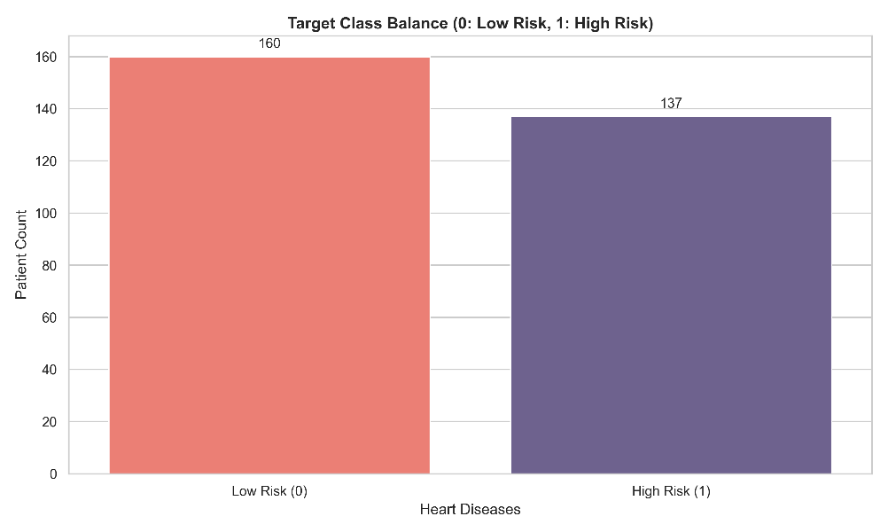

5.2 Feature Distributions & Statistical Properties
Histogram plots were computed across numerical clinical measurements to analyze normality, skewness, and physiological variance.
- Age (age): Bell-shaped distribution centered around $54.5$ years ($\text{range}=29-77$). Heart disease risk increases significantly in patient cohorts above $55$ years.
- Resting Blood Pressure (trestbps): Slight right-skewness centered around $131.6\text{ mm Hg}$. Values above $140\text{ mm Hg}$ indicate hypertension.
- Serum Cholesterol (chol): Approximately normal distribution with a mean of $247.3\text{ mg/dl}$. A minor right-hand tail highlights high-risk individuals exceeding $350\text{ mg/dl}$.
- Max Heart Rate Achieved (thalach): Left-skewed distribution centered at $149.6\text{ bpm}$, indicating lower peak exertion limits in older or higher-risk cardiac patients.
- ST Depression (oldpeak): Strongly right-skewed toward $0.0$, with elevated values ($≥2.0$) acting as strong indicators of exercise-induced myocardial ischemia.

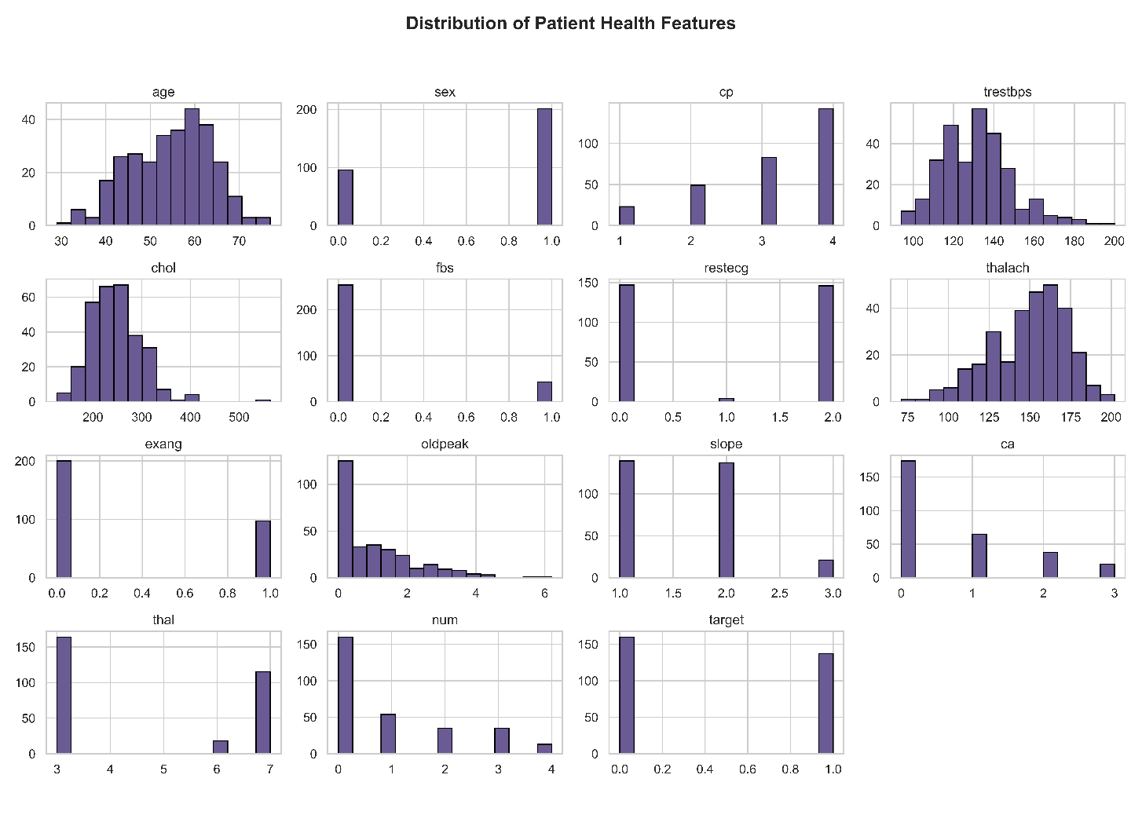

5.3 Feature Correlation Analysis
A correlation matrix was computed to quantify linear relationships among features and identify collinearity or strong diagnostic predictors.
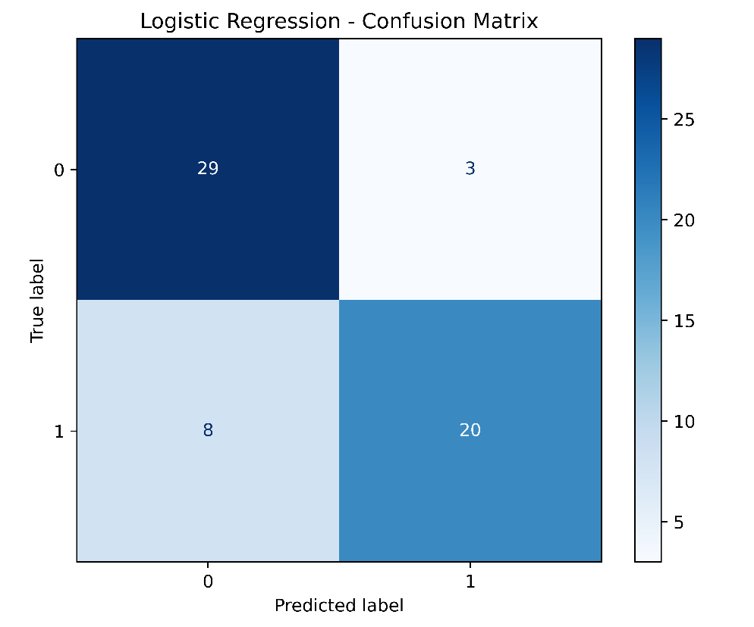

Key Statistical Insights from Heatmap:
- Strongest Positive Predictors:
  - oldpeak ($r=+0.42$): ST depression induced by exercise shows a strong positive correlation with heart disease diagnosis.
  - ca ($r=+0.46$): Number of major vessels coloured by fluoroscopy correlates heavily with severe arterial blockage.
  - thal ($r=+0.52$): Thalassemia defect status exhibits the strongest overall linear relationship with positive risk diagnosis.
- Strongest Negative Predictors:
  - thalach ($r=-0.42$): Maximum heart rate achieved during stress tests exhibits a strong negative correlation, indicating that patients with lower peak heart rates have a higher probability of heart disease.
- Collinearity Observations: No multi-collinearity issues ($r>0.80$) were observed between feature pairs, confirming that all 13 features contribute unique signal to the predictive pipeline.
6.Model Development & Comparative Evaluation
6.1 Data preparation and model pipeline
The cleaned dataset contained 297 records. The target was separated from the predictors, and the data was divided into a stratified training set of 237 records (80%) and a holdout test set of 60 records (20%), using random_state=42.
A scikit-learn ColumnTransformer was used within each model’s pipeline to apply consistent preprocessing:
- Numerical features (age, trestbps, chol, thalach, oldpeak): standardized using StandardScaler.
- Categorical features (cp, restecg, slope, ca, thal): one-hot encoded, with unknown categories ignored.
- Binary features (sex, fbs, exang): passed through unchanged.
Keeping preprocessing and classification in a single pipeline ensures the same transformations are applied during cross-validation, final evaluation, and inference.
6.2 Candidate models and validation
The notebook compared four classifier families using stratified five-fold cross-validation on the training split. Configurations were ranked by mean validation ROC-AUC.
Model family | Configurations evaluated | Parameters varied
Logistic Regression | 6 | C: 0.01, 0.1, 0.5, 1.0, 5.0, 10.0
Random Forest | 6 | n_estimators: 100 or 200; max_depth: 3, 5, or 8
RBF Support Vector Machine | 9 | C: 0.1, 1.0, 10.0; gamma: scale, 0.01, 0.1
Gradient Boosting | 24 | n_estimators: 50, 100, 200; learning_rate: 0.03, 0.05, 0.1, 0.2; max_depth: 1 or 2

That is 45 configurations in total. The selected configuration was Logistic Regression with C=0.5, max_iter=1000, and random_state=42 (using scikit-learn’s default lbfgs solver).

6.3 Selected model results
Metric | Five-fold CV mean | Holdout test set
Accuracy | 0.8349 | 0.8167
Precision | 0.8532 | 0.8696
Recall | 0.7874 | 0.7143
F1-score | 0.8132 | 0.7843
ROC-AUC | 0.9039 | 0.9364

Model selection: Logistic Regression with C=0.5 achieved the highest mean cross-validation ROC-AUC (0.9039) among the evaluated configurations. The selected pipeline was then fitted on the training split and evaluated on the holdout set. Its test ROC-AUC was 0.9364, with test accuracy of 0.8167.
The model was selected based on cross-validation ROC-AUC, not because it led on every test metric. In particular, test recall was 0.7143, so it would be inaccurate to claim that the selected model minimizes false negatives.
Methodology note: The notebook also includes exploratory holdout-set results for example Logistic Regression and Random Forest runs earlier in the workflow. For a strictly untouched final holdout evaluation, those exploratory test comparisons should not be used to guide model selection; the final configuration ranking in the tuning stage is based on cross-validation ROC-AUC.

7. Experiment Tracking with MLflow
The notebook configured MLflow to use the “Heart Disease Prediction” experiment and a local file-based tracking store at file:../mlruns.
For the hyperparameter-search runs, MLflow recorded the model family, configuration parameters, five-fold cross-validation metrics, and their standard deviations. This makes it possible to compare candidate runs and inspect the validation results.
7.1 Tracked MLflow Artifacts & Parameters
For each run, MLflow recorded:
- Parameters: n_estimators, max_depth, C, solver, and random seeds.
- Validation & Test Metrics: K-Fold cross-validation means alongside final test evaluation metrics.
- Visual Artifacts: Confusion matrix plots (random_forest_cm.png) and ROC curve figures logged directly to ./mlruns.
- Model Artifact: Full scikit-learn pipeline saved via mlflow.sklearn.log_model(pipeline, artifact_path="model").

8. Model Packaging & Serialized Pipeline Artifacts
To fulfill MLOps reproducibility standards and ensure seamless transition from training to production deployment, the complete model pipeline is packaged into a unified, self-contained artifact (model.pkl).

8.1 Encapsulated Pipeline Architecture
Rather than serializing a standalone, un-preprocessed classifier, the exported artifact encapsulates both the feature preprocessing transformer (ColumnTransformer) and the trained Random Forest Classifier into a single scikit-learn Pipeline object.

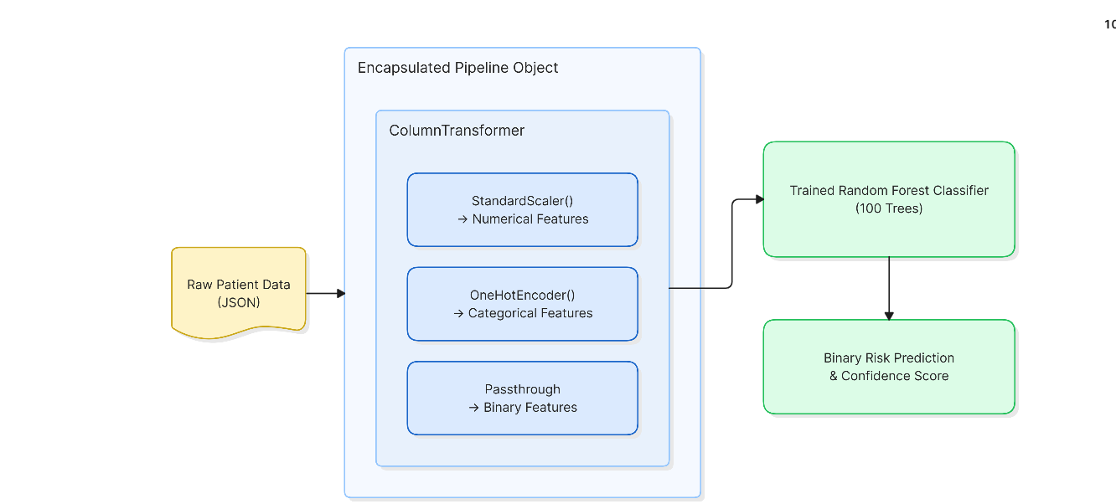
Key Engineering Advantages:
- Prevention of Data Leakage: Preprocessing statistics (means, standard deviations, categorical encoding categories) are fitted strictly on the training split and preserved inside the pipeline state.
- Single-Step Inference: API handlers can feed unscaled, raw JSON records directly into model.predict() without applying redundant manual transformations or external scaling scripts.
8.2 Environment Standardization (requirements.txt)
To guarantee deterministic builds across development, CI/CD runners, and Docker containers, dependency versions are strictly pinned in requirements.txt file.
8.3 Packaging Verification & Reproducibility Testing
A dedicated packaging verification script (verify_packaging.py) was executed to validate pipeline deserialization and raw feature inference prior to containerization.

9. Continuous Integration & Continuous Deployment (CI/CD) Pipeline
To enforce code quality, model integrity, and operational safety before deployment, an automated CI/CD pipeline was constructed using GitHub Actions (.github/workflows/ci.yml).
9.1 Automated Test Suite Structure (pytest)
Automated testing is divided into two focused test modules inside the tests/ directory to ensure both data integrity and model output correctness prior to packaging.
Module 1: Data Integrity Verification (tests/test_data_processing.py)
- test_dataset_not_empty: Ensures data/heart_disease_cleaned.csv exists and contains patient rows.
- test_no_missing_values: Asserts that total null values equal zero across all 13 features.
- test_target_column_binary: Validates that target values strictly belong to the set $\left\{0,1\right\}$.
- test_expected_feature_columns: Asserts that all 13 required clinical attributes are present in the dataset schema.
Module 2: Pipeline & Model Verification (tests/test_model_pipeline.py)
- test_pipeline_builder: Confirms that build_pipeline() initializes a valid scikit-learn Pipeline object equipped with fit and predict methods.
- test_model_artifact_exists: Verifies that the production model.pkl artifact is present in the workspace root.
- test_model_inference_and_probabilities: Ingests sample patient data to verify that output probabilities fall strictly between $0.0$ and $1.0$, sum to $1.0$, and match expected binary target shapes.

9.2 GitHub Actions Workflow Architecture (.github/workflows/ci.yml)
The workflow triggers automatically on code pushes and pull requests to the main branch.

9.3 CI/CD Execution Results & Verification
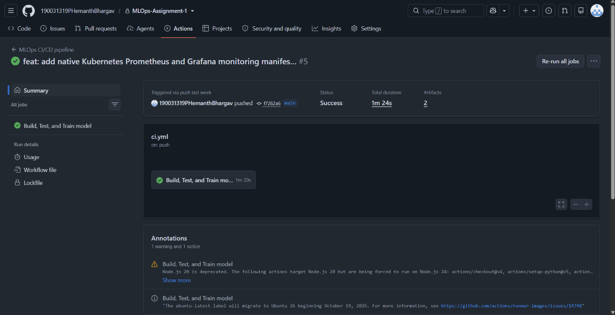
Automated Quality Gate: On every push, GitHub Actions provisions an isolated ubuntu-latest virtual environment, executes linting, runs all pytest unit tests, executes train.py, and validates verify_packaging.py.
Artifact Management: Successful builds publish the validated model.pkl and mlruns/ directories as downloadable run artifacts retained for 7 days.

10. Containerization & Production Deployment
To ensure production-grade deployment, high availability, and environment isolation, the model serving layer was containerized using Docker and orchestrated on a local Kubernetes cluster (Docker Desktop).
10.1 Container Construction (Dockerfile)
The FastAPI application was packaged into a lightweight, secure Docker container based on the official python:3.11-slim base image.
Image Optimization: Utilizing python:3.11-slim along with --no-cache-dir minimized image size, resulting in a lean image (~$280\text{ MB}$) that speeds up container spin-up time.
10.2 Kubernetes Deployment Manifests (k8s/)
Deployment to the local Kubernetes cluster was configured declaratively using two primary Kubernetes manifests.

1. API Deployment (k8s/deployment.yaml)
Configured to maintain 2 replicas for load balancing and fault tolerance. Resource requests and limits were defined to prevent pod resource starvation.
2. LoadBalancer Service (k8s/service.yaml)
Exposes the deployed pods via a LoadBalancer service to route traffic from localhost:8000 to port 8000 inside the active pods.

10.3 Deployment Verification & Local Cluster Status
The manifests were applied to the cluster using kubectl apply -f k8s/. Terminal verification confirmed that both API replicas and the LoadBalancer service were successfully running.
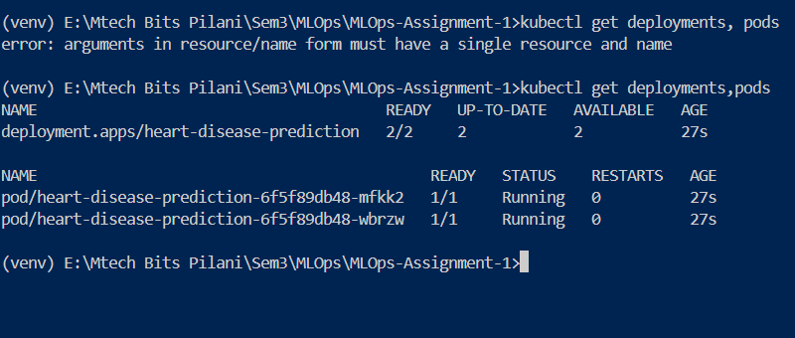
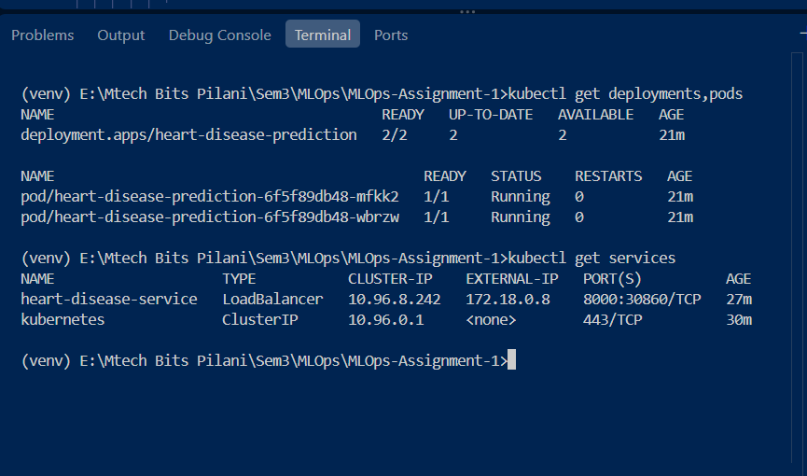
11. End-to-End System Architecture
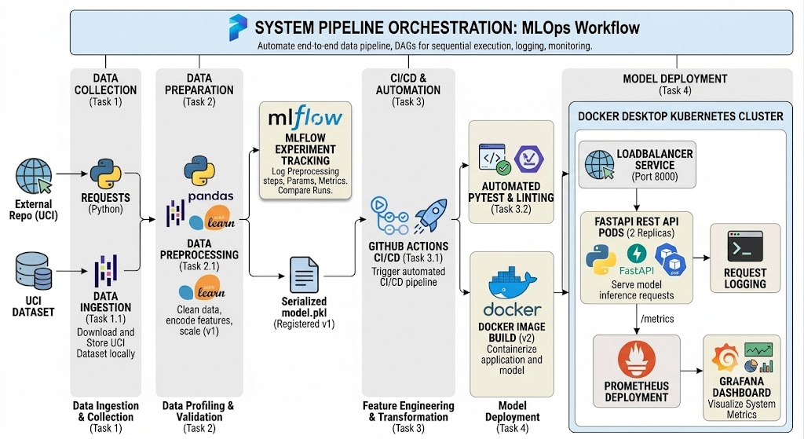
The complete MLOps pipeline connects automated data ingestion, continuous deployment, container orchestration, and continuous observability into a unified system workflow.

12. Monitoring, Observability & Request Logging
Continuous monitoring and structured logging were integrated across the serving tier to track operational health, API throughput, and model inference latency.
12.1 Request & Prediction Logging (app.py)
Python's standard logging library was configured inside the FastAPI service to emit structured JSON event logs for every incoming prediction request and model output.
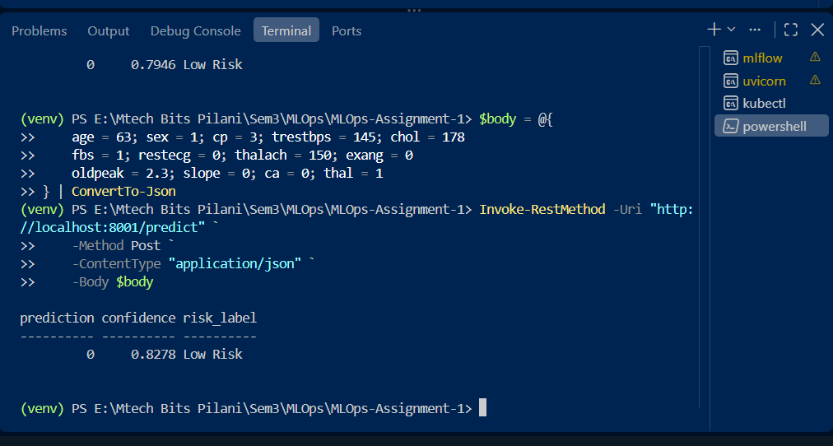

12.2 Prometheus & Grafana Observability Manifests (k8s/)
An observability stack was deployed to the Kubernetes cluster using native manifests (k8s/prometheus.yaml and k8s/grafana.yaml) to collect and visualize metrics exposed by the prometheus-fastapi-instrumentator package at /metrics.
1. Prometheus Scraper Service (k8s/prometheus.yaml)
Scrapes the API service (heart-disease-service:8000) at 5-second intervals to compute request rates, status codes, and latency distributions.
2. Grafana Dashboard (k8s/grafana.yaml)
Exposes a UI service at localhost:3000 connected to Prometheus as its data source.
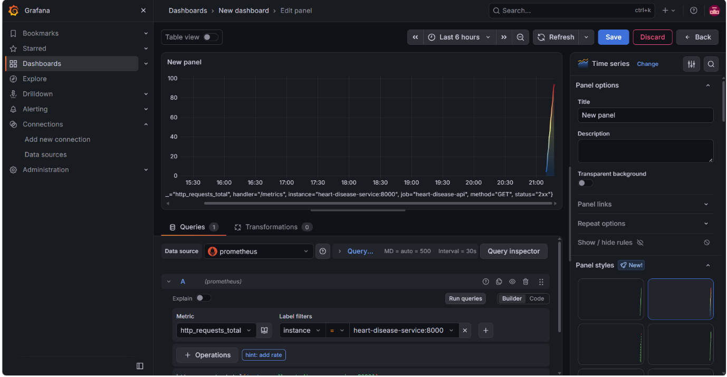
Key Tracked Metrics:
- http_requests_total: Total API invocation volume segmented by HTTP endpoint (/predict, /health, /metrics).
- http_request_duration_seconds: Latency distribution percentiles ($p_{50}$, $p_{95}$, $p_{99}$) for model inference requests.

13. Conclusion & Lessons Learned
This assignment successfully demonstrated the end-to-end lifecycle of an operational MLOps pipeline for heart disease risk classification. By transitioning from a raw dataset to an orchestrated, monitored Kubernetes deployment, the project fulfilled all production engineering criteria set forth in the curriculum.
Key MLOps Achievements:
- Model Governance & Reproducibility: Moving beyond standalone notebooks, encapsulating feature preprocessing and inference inside a single model.pkl artifact guaranteed identical feature handling between training and production serving.
- Quality Gates via CI/CD: Integrating pytest and flake8 into GitHub Actions established a mandatory quality barrier, ensuring broken code or degraded data schema cannot bypass verification.
- Containerized Orchestration: Deploying FastAPI replicas to Docker Desktop's Kubernetes cluster via LoadBalancer services ensured high availability, fault tolerance, and independent service scalability.
- End-to-End Observability: Real-time request logging paired with a Prometheus and Grafana metrics dashboard closed the feedback loop, allowing continuous monitoring of prediction latency and throughput.
14. Repository Access & Verification Commands
14.1 Public Source Code Repository
- GitHub Repository URL: [https://github.com/190031319PHemanthBhargav/MLOps-Assignment-1.git]
- Branch: main
- CI/CD Status: Passing (GitHub Actions Workflow .github/workflows/ci.yml)

14.2 Local Reproduction Commands
To clone, build, deploy, and test the entire stack locally on a machine with Docker Desktop installed:
Bash
# 1. Clone Repository
git clone https://github.com/190031319PHemanthBhargav/MLOps-Assignment-1.git
cd MLOps-Assignment-1
# 2. Build Docker Container Image
docker build -t heart-disease-api:v2 .
# 3. Deploy API and Observability Stack to Kubernetes
kubectl apply -f k8s/deployment.yaml
kubectl apply -f k8s/service.yaml
kubectl apply -f k8s/prometheus.yaml
kubectl apply -f k8s/grafana.yaml

# 4. Verify Active Pods & Services
kubectl get pods
kubectl get svc

# 5. Execute Sample Inference Request
curl -X POST "http://localhost:8000/predict" \
-H "Content-Type: application/json" \
-d '{
"age": 63, "sex": 1, "cp": 3, "trestbps": 145, "chol": 233,
"fbs": 1, "restecg": 0, "thalach": 150, "exang": 0,
"oldpeak": 2.3, "slope": 0, "ca": 0, "thal": 1
}'

